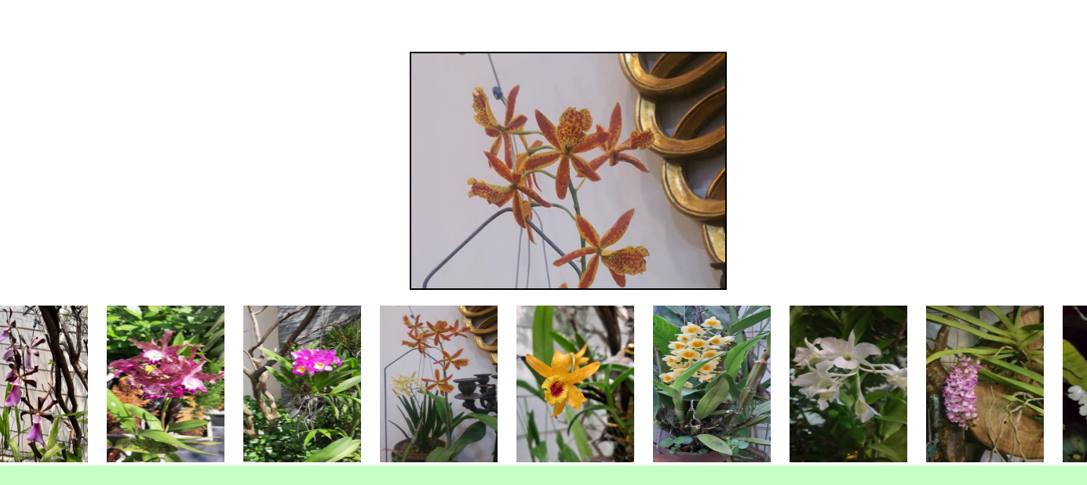

1. Click Image and change background image of div
2. Check if name or email or content is empty, show mess “please fill all field”

else show mess “mess sent”

when user click “ok” then reset form

when user click “cancel” then do nothing

